**Market Segmentation Analysis of Electric Vehicles Market in India**

**Contributors**

Neeharika Ravi, Harika Vemula, Amal Ashok, Sumit Shingne

Date: 8th, June, 2025



**Problem Statement:**

Task is to analyse the Electric Vehicles Market in India using Segmentation analysis and come up with a feasible strategy to enter the market, targeting the segments most likely to use their product in terms of Geographic, Demographic, Psychographic, and Behavioural.

In this report we analyse the Electric Vehicles Market in India using segments such as region, price, charging facility, type of vehicles (e.g., 2 wheelers, 3 wheelers, 4 wheelers etc.), retail outlets, manufacturers, safety, plug types and much more.

**1. Introduction**

The Indian electric vehicle (EV) market is experiencing rapid growth, driven by government policies, rising fuel costs, and environmental awareness. This report analyses market segmentation to identify consumer groups most likely to adopt EVs and proposes a market entry strategy. It leverages datasets on EV sales by state and manufacturer, predictive battery life modelling, and Fermi estimation to quantify segment potential.

**Objectives**

* Segment the Indian EV market by demographic, geographic, psychographic, and behavioural factors.
* Analyse preferences for 2-wheelers, 3-wheelers, and 4-wheelers.
* Evaluate battery performance’s role in consumer choice.
* Develop a feasible market entry strategy for high-potential segments.

**Background**

India’s EV market is projected to grow significantly, with 2-wheelers dominating (~80% of sales) due to affordability and urban mobility needs. The FAME II scheme and state-level incentives have accelerated adoption, particularly in urban areas. Understanding segment preferences is critical for tailoring products and strategies.

**2. Data Description**

The analysis uses the following datasets:

* dim_date.csv: 36 entries with columns `date`, `fiscal_year`, `quarter` (April 2021–March 2024).
* electric_vehicle_sales_by_makers.csv: Sales by EV manufacturers, with dates converted to datetime format.
* electric_vehicle_sales_by_state.csv: State-wise EV sales, also with datetime formatting.
* Indian Automobile buying Behaviour.csv: Contains all the columns like age, salary, wife_salary, loan to estimate the affordability of EV vehicle.
* ev_battery_charging_data.csv: Contains columns like Degradation, charging time, efficiency, SoC to findout optimal temperature, predictive maintenance.
* ev_charging_stations_india.csv: It has all the electric vehicles charging stations information
* ev_blast_dataset.csv: It contains battery_type, external_abuse, short_circuits etc as its columns, used to find if the battery is in poor condition.
* ElectricCarData_Clean.csv: It has all the information regarding the car brand, rapid charge, accelspeed, Efficiency_WhKm.
* EV_sales.csv: Has the sales data over the years
* Metadata.csv: It is a NASA battery dataset that contains type, ambient_temperature, capacity, Re, Rct
* EV_Data.csv: The dataset contains rich demographic information of respondents, including their age, city, profession, marital status, education level, number of family members, and annual income.
* Credit_data.csv: The dataset contains columns like age, profession, loan amount, loan tenure, number of loans, credit score etc which helps to find whether a person can afford an Electric Vehicle or not.

**Data Collection:**

<https://vahan.parivahan.gov.in>

<https://power.larc.nasa.gov>

<https://github.com>

<https://www.plugshare.com>

<https://app.cpcbccr.com/ccr/#/caaqm-dashboard-all/caaqm-landing>

<https://www.kaggle.com>

[https://www.india-briefing.com/news/indias-ev-manufacturing-capacity-and-market-preferences- progress-25840.html/](https://www.india-briefing.com/news/indias-ev-manufacturing-capacity-and-market-preferences-%20progress-25840.html/)

**Preprocessing**

Dates were standardized using `pd.to_datetime` with `dayfirst=True`. The `dim_date` dataset has 36 rows and 3 columns, with no missing values (`date_df.info()` and `date_df.describe()`).

Null values were filled with median and outliers are handled either by replacing them with median or dropping them. State names and city names were changed to maintain consistency and readability.

Compound Annual Growth Rate (CAGR) : Used to track growth over time

* CAGR = (Ending or max value)/ (Beginning or min value) ** (1/ years) - 1

Penetration Rate: Used to measure market share or adoption level at a point of time

* Penetration Rate (%) = (EV Sales/ Total Vehicle Sales) * 100

The above two are calculated to check the growth and sales rate overtime.

**Battery Life Prediction**

A neural network model predicts battery life using:

* Features: `type_discharge` (charge/discharge), `Capacity`, `Re`, `Rct`.
* Performance: Mean Squared Error (MSE) of 4449.05.
* Example Predictions:
  + Discharge, Capacity=1.674305, Re=-4.976500e+11, Rct=1.055903e+12 → 26.15 units.
  + Charge, Capacity=20.5, Re=-2.983215e+11, Rct=1.223456e+12 → 340.93 units.

**3. Market Segmentation:**

Demographic Segmentation

* Age: Young professionals (18–35 years) favor 2-wheelers for affordability. Families (35–50 years) prefer 4-wheelers for safety.
* Income: Middle-income (INR 5–15 lakh annually) dominates 2-wheeler purchases; high-income (INR 15 lakh+) prefers 4-wheelers.
* Occupation: Urban professionals and small business owners adopt EVs for fuel savings.

Young Professionals - Age 18–35, middle-income, prefer 2-wheelers, tech-savvy.

Families - Age 35–50, high-income, prefer 4-wheelers, value safety.

Small Businesses - Delivery/transport sectors, cost-driven, prefer 3-wheelers.

Geographic Segmentation

* Urban Areas: Maharashtra, Karnataka, Delhi lead due to charging infrastructure.
* Rural Areas: Low adoption due to limited infrastructure.
* Regional Trends: Southern/western states show faster growth.

Urban (e.g., Maharashtra, Delhi) - High adoption, 2-wheelers dominant, robust infrastructure.

Rural - Low adoption, limited infrastructure, prefer low-cost 2-wheelers.

Southern/Western States - Rapid growth, supportive policies, mixed vehicle types.

Psychographic Segmentation

* Environmentally Conscious: Prioritize low emissions.
* Tech Enthusiasts: Seek smart features (e.g., connectivity).
* Cost-Conscious: Focus on affordability, prefer 2-wheelers.

Eco-Conscious - Low emissions, efficient batteries.

Tech Enthusiasts - Connectivity, range, performance.

Cost-Conscious - Affordability, prefer 2-wheelers.

Behavioural Segmentation

* Purchase Patterns: First-time buyers prefer established brands (e.g., Tata). Repeat buyers explore new entrants.
* Usage Patterns: Commuters favor 2-wheelers; commercial users choose 3-wheelers/4-wheelers.
* Loyalty: Moderate, driven by price/performance.

First-Time Buyers - Prefer established brands, focus on reliability.

Commercial User - High usage, prefer 3-wheelers/4-wheelers, cost-driven.

Repeat Buyers - Open to new brands, prioritize performance.

**4. Exploratory Data Analysis**

**a. Makers Data**

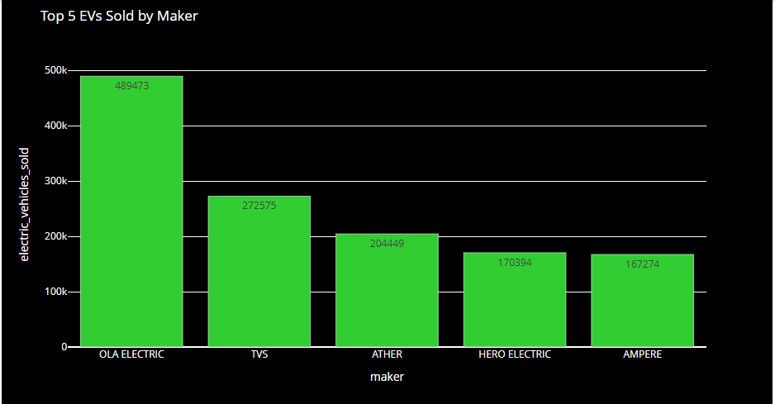

The above includes both 2 wheeler and 4 wheeler makers. From the above, it is clear that OLA ELECTRIC are sold the most Electric Vehicles.

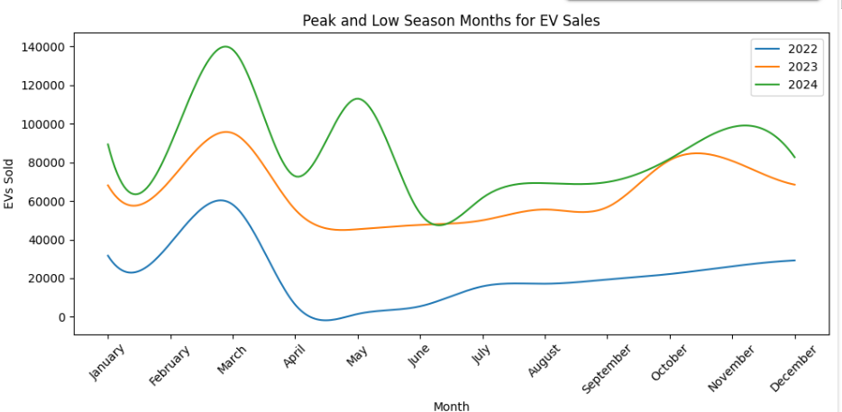

Sales are high in the beginning of the years and the same pattern is being seen across all the years. It might be because of lower sale prices or the showrooms trying to get the new models etc.

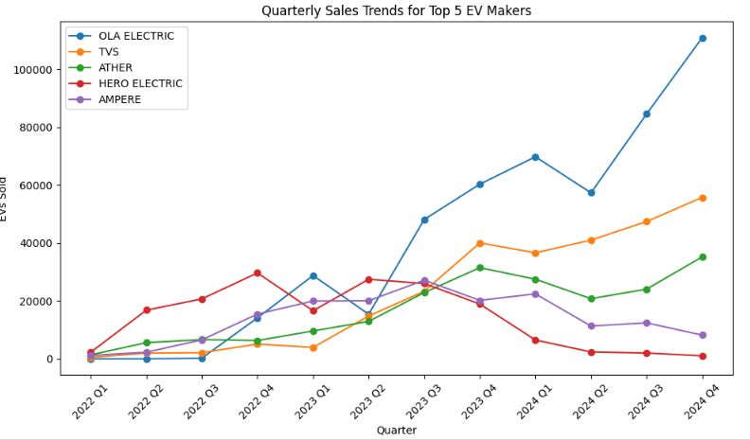

For the top 3 sellers, the sales are high in the 4th quarter.

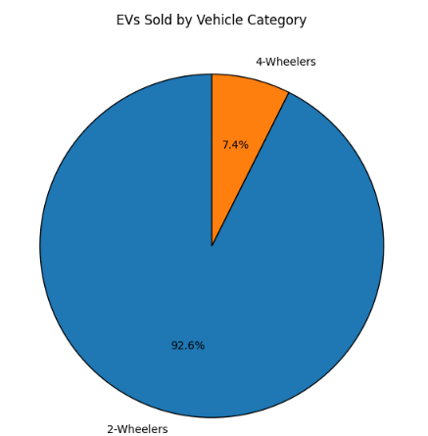

Around 93% of Indian population prefer 2 wheelers.

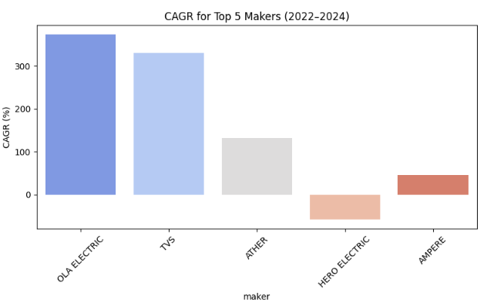

The above chart is Compound Annual Growth Rate and Hero Electric is going in negative direction, whereas Ola Electric has the highest CAGR.

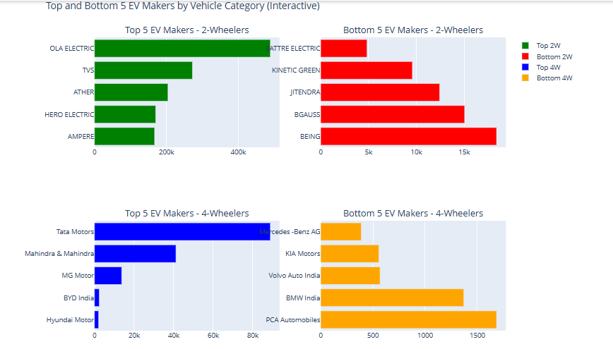

**b. State wise Sales**

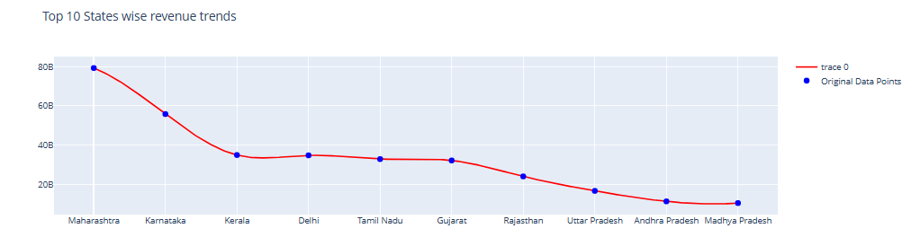

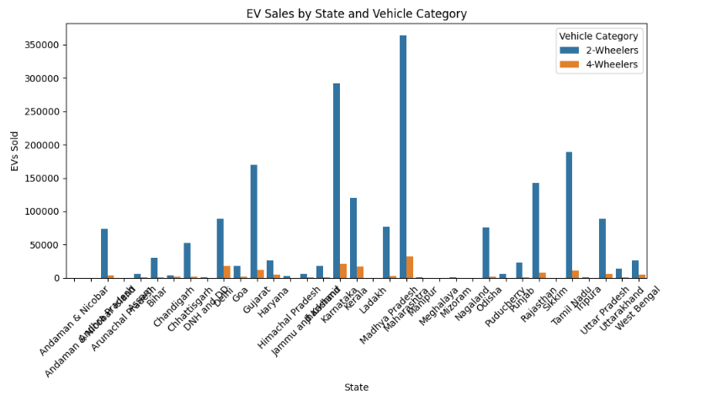

2 wheelers are sold highest in almost all the states.

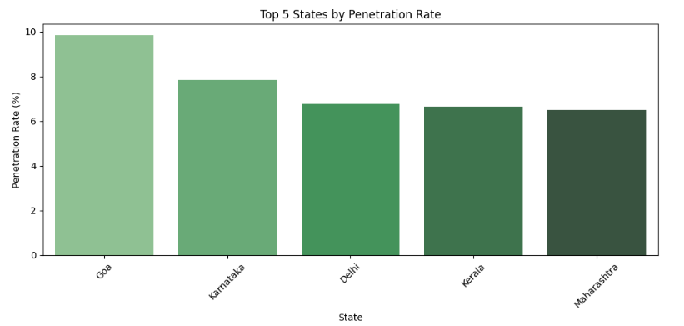

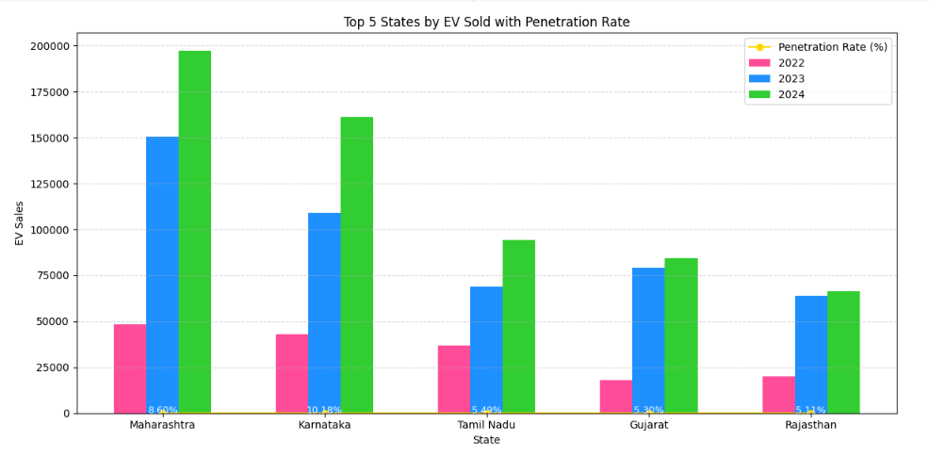

**c. Consumer Behaviour**

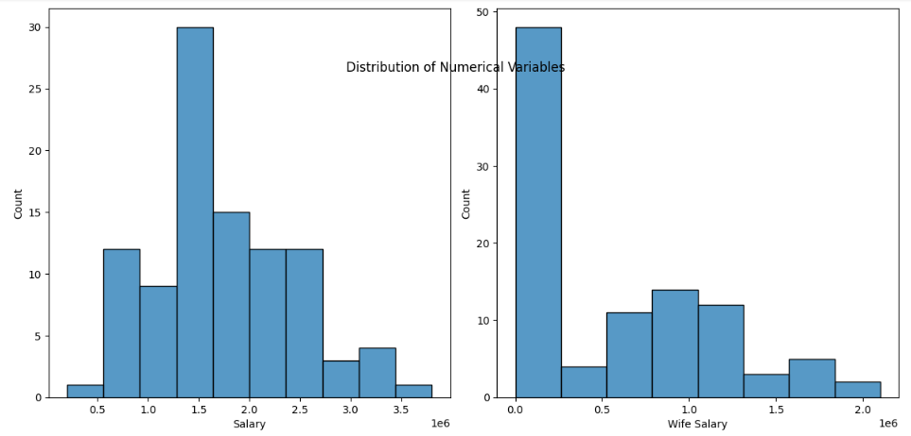

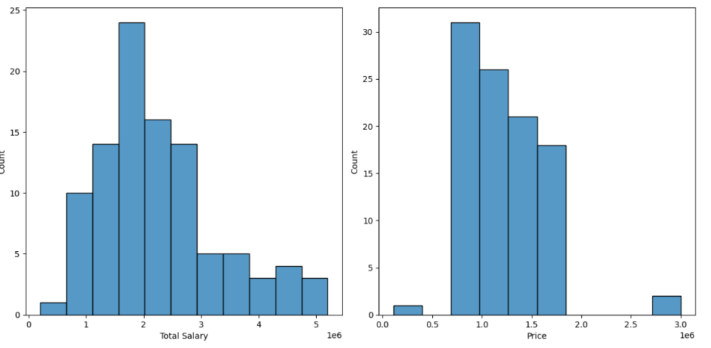

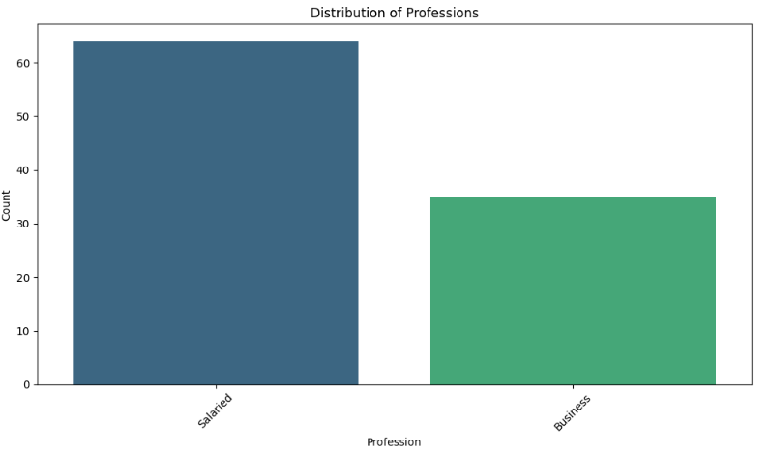

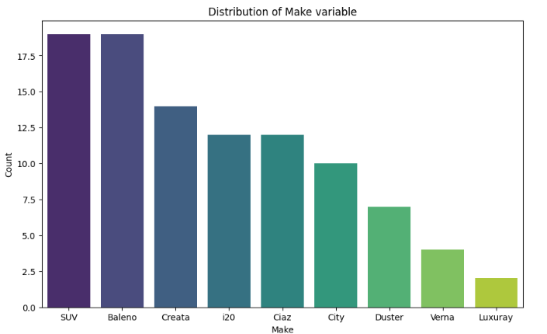

SUVs are sold a lot as it might be family friendly as it is spatial and has more comfort that small cars with same number of seats.

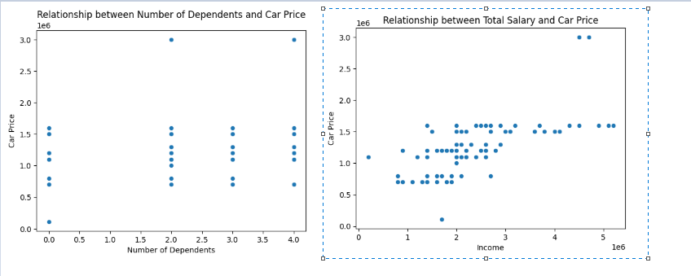

There is no proper relationship between number of dependents and car price whereas a positive relationship is seen between total salary and car price.

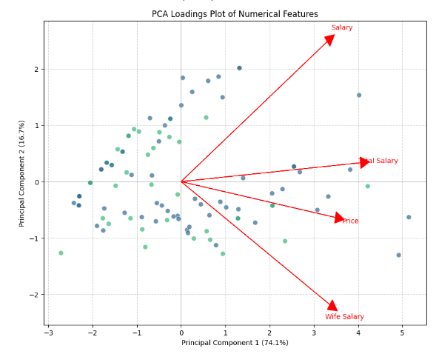

**d. Battery:**

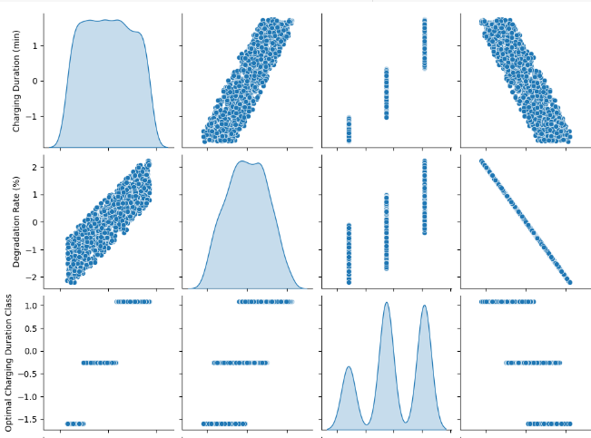

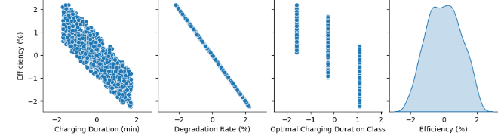

Relationships observed:

* Charging Duration (min) and Efficiency (%): Strong negative linear correlation: as duration increases, efficiency decreases. Longer charging durations may reduce battery efficiency.
* Charging Duration vs Degradation Rate: Positive linear correlation. Longer charging durations correlate with increased degradation rate.
* Efficiency vs Degradation Rate: Strong negative correlation (almost perfect line). As degradation rate increases, efficiency decreases sharply. Indicates that degradation directly affects efficiency.

Practical Insights:

* Shorter durations usually correlate with better efficiency and less degradation.
* High degradation directly reduces efficiency, indicating the importance of minimizing degradation.
* Battery efficiency and charging duration show clear inverse relationship.

Actionable insights from this analysis:

* Optimal charging practices should prioritize shorter charging times to maintain efficiency.
* Strategies should consider balancing charging duration and acceptable degradation rates.

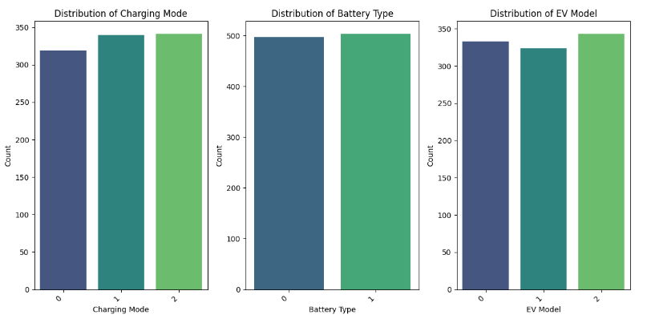

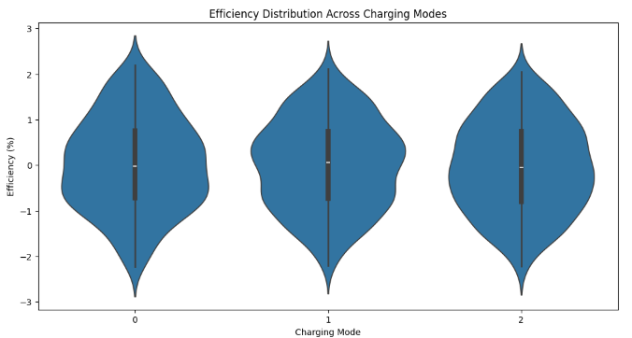

This shows that it is not a significant factor.

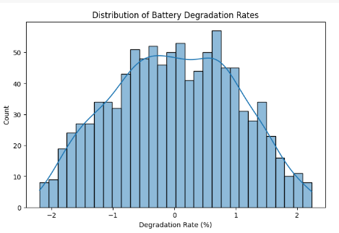

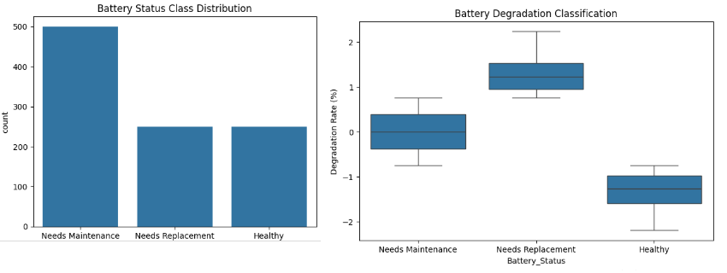

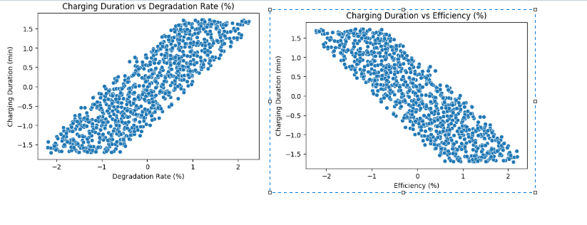

Degradation Rate vs. Charging Duration

* Strong positive correlation → As degradation increases, charging time increases.
* Likely cause: Older/degraded batteries may charge slower due to efficiency loss.

Efficiency vs. Charging Duration

* Strong negative correlation → More efficient batteries charge faster.
* Likely cause: Lower efficiency means more energy is lost as heat, extending charging time.

**e. Charging Stations:**

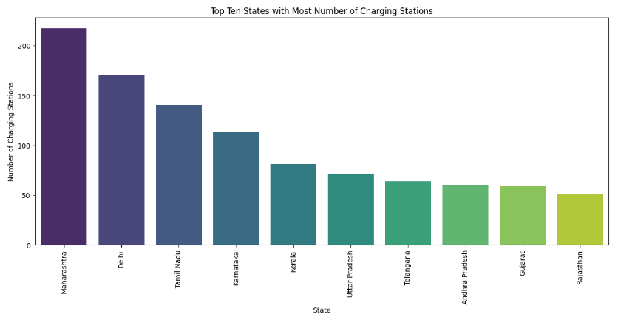  
This makes absolute sense as the number of electric vehicles are sold highest in Maharastra and Delhi from state wise sales data. So, more number of charging stations should be present in these states.

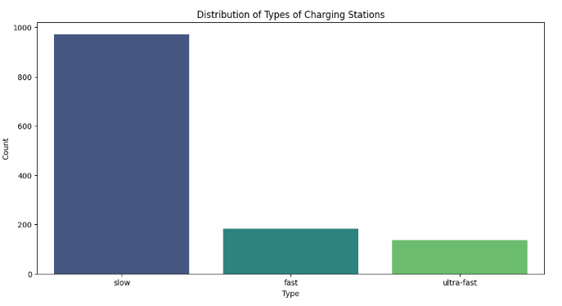

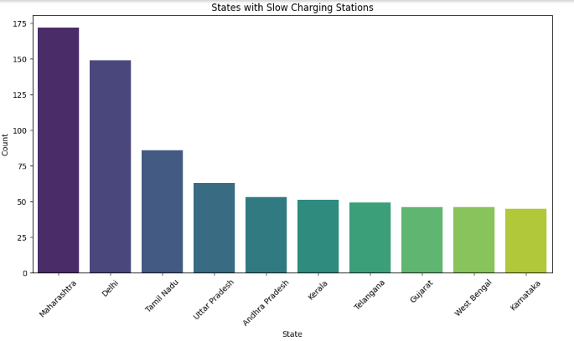

**f. Battery Blast (Synthetic dataset from Kaggle)**

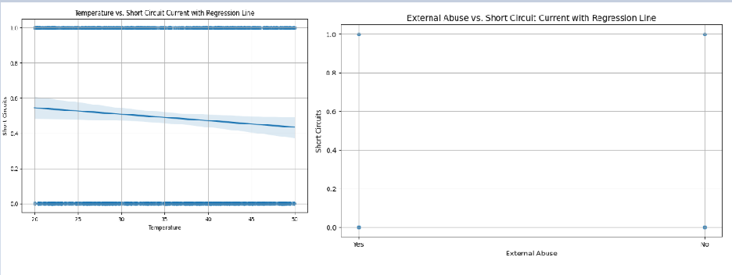

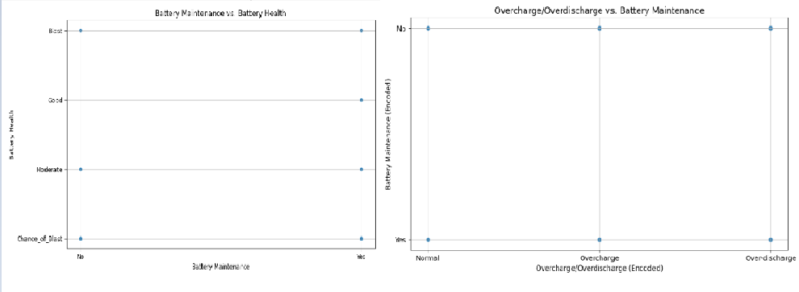

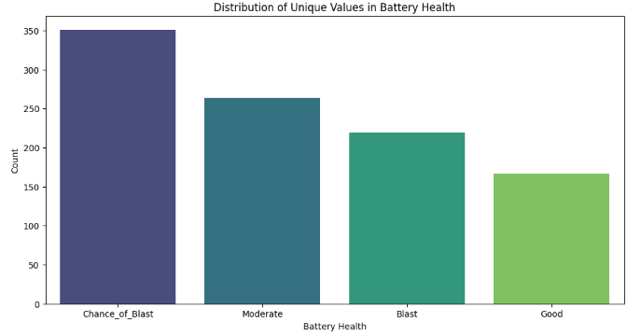

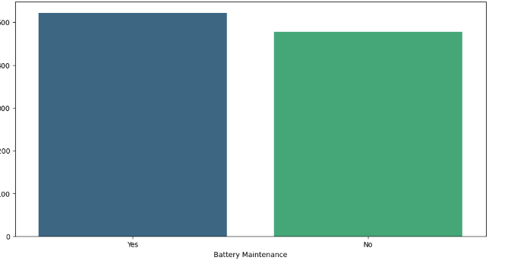

Since this is a synthetic dataset, no much relationship is found among the variables.

**g. Vehicle Specifications:**

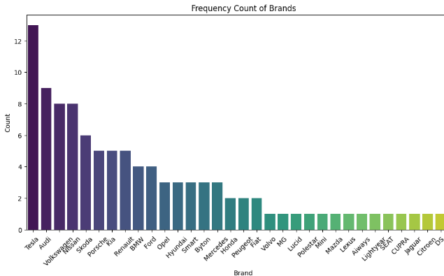

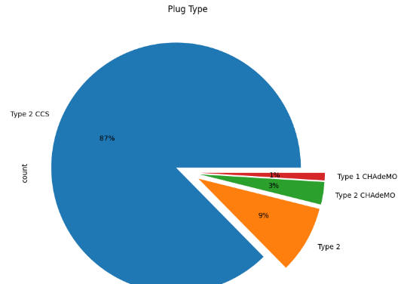

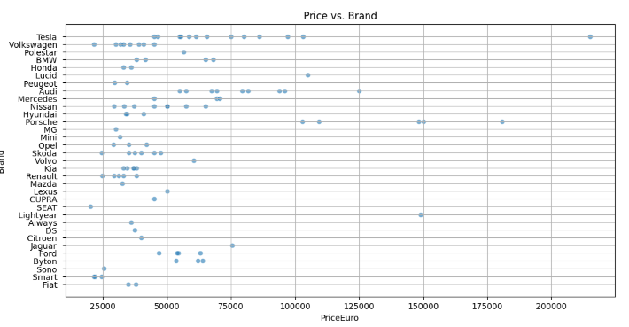

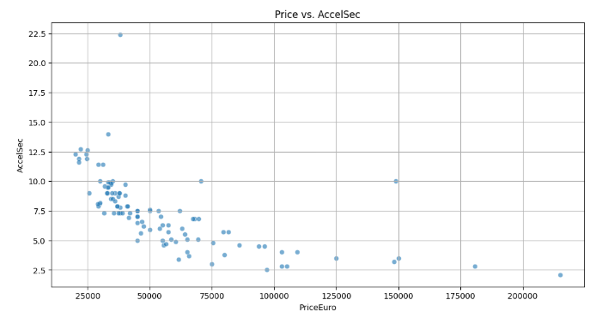

As the price increases, the AccelSec is decreasing. They might be negatively correlated.

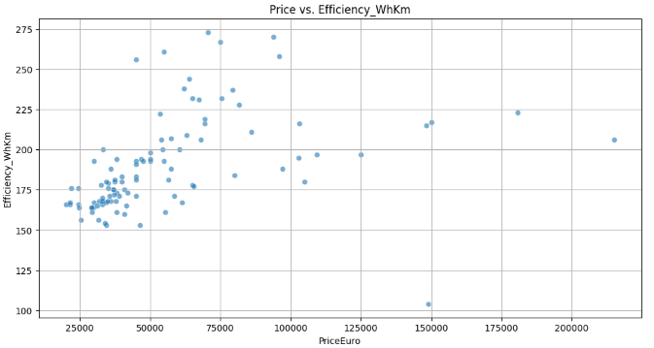

It is clear that there is a linear relationship between price and efficiency.

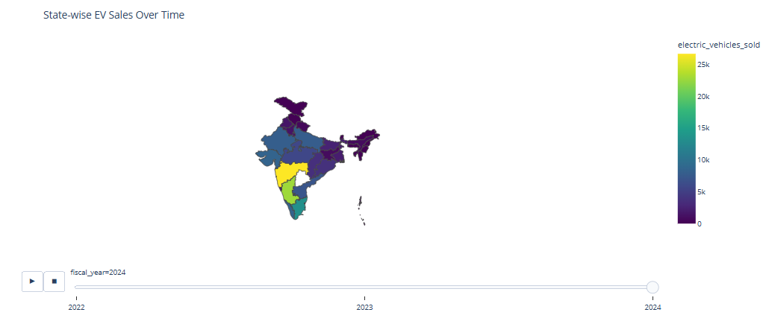

From the above map, it is clear that over the time, the sales of the electric vehicles increased.

**h. Credit Data**

The below is a pie chart of different occupations and the respective percentages.

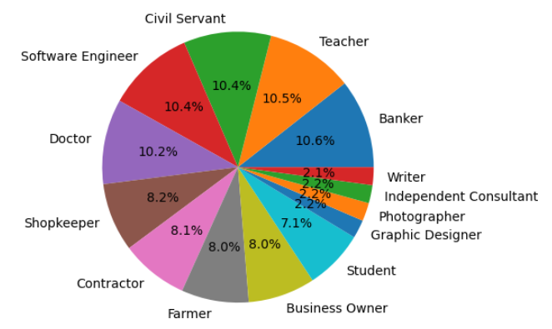

**5. Segment Extraction**

**a. K-Means**

K-Means Clustering is one of the most popular Unsupervised Machine Learning Algorithms Used for Solving Classification Problems. K Means segregates the unlabeled data into various groups, called clusters, based on having similar features, common patterns. Suppose we have N number of Unlabeled Multivariate Datasets of various features like water-availability, price, city etc. from our dataset. The technique to segregate Datasets into various groups, on the basis of having similar features and characteristics, is called Clustering. The groups being formed are known as Clusters. Clustering is being used in Unsupervised Learning Algorithms in Machine Learning as it can segregate multivariate data into various groups, without any supervisor, on the basis of a common pattern hidden inside the datasets.

In the Elbow method, we are actually varying the number of clusters (K) from 1 – 10. For each value of K, we are calculating WCSS (Within-Cluster Sum of Square). WCSS is the sum of squared distance between each point and the centroid in a cluster. When we plot the WCSS with the K value, the plot looks like an Elbow. As the number of clusters increases, the WCSS value will start to decrease. WCSS value is largest when K = 1. When we analyze the graph, we can see that the graph will rapidly change at a point and thus creating an elbow shape. From this point, the graph starts to move almost parallel to the X-axis. The K value corresponding to this point is the optimal K value or an optimal number of clusters.

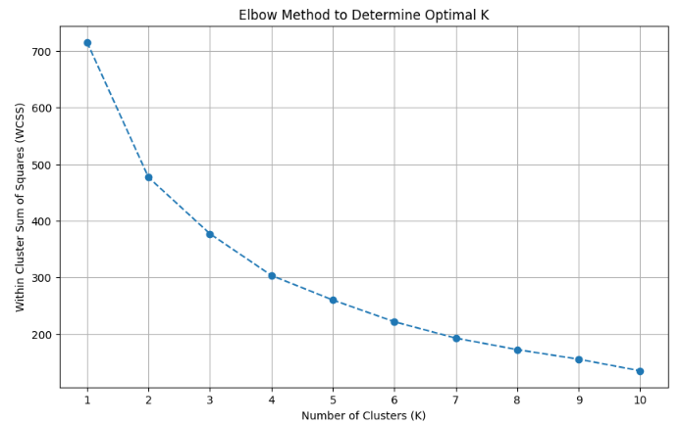

**Behavioural Segmentation:**

Segmenting Consumers based on Behavior and Attributes (Clustering): If you want to group consumers with similar buying behaviors or attributes, clustering models are suitable.

* K-Means Clustering: A popular algorithm for partitioning data into a predefined number of clusters.
* DBSCAN: Can find clusters of varying shapes and handle noise.

In this notebook, K-Means has been used.

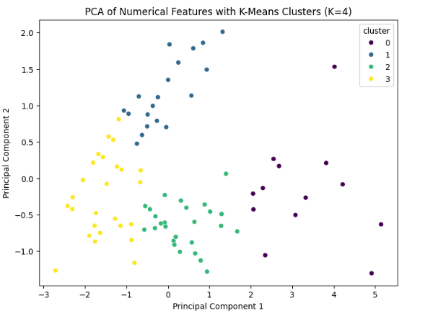

**Geographic Segmentation:** Segmenting the market based on geography. This mainly includes characteristics of the market based on the location.

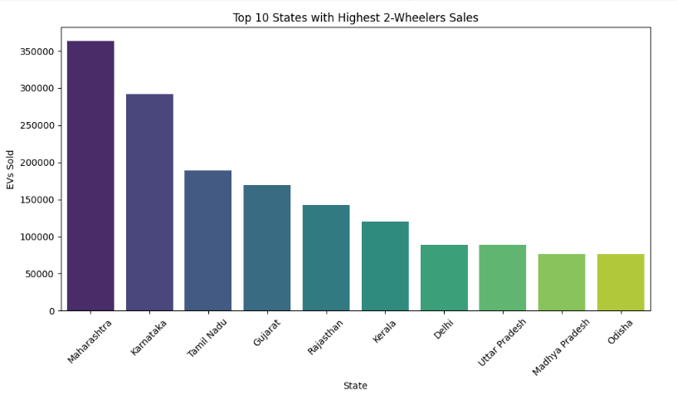

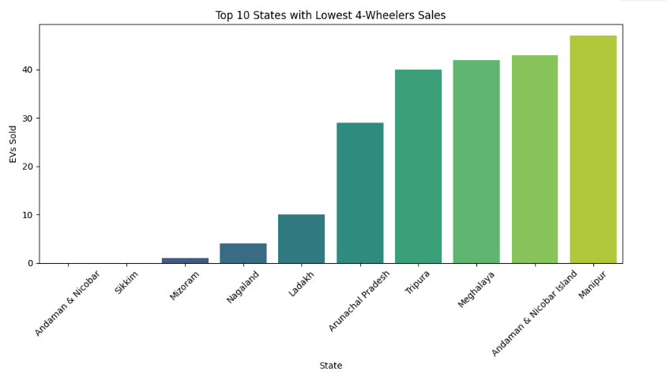

**Demographic Factors**

Major demographic factors to consider – age, income, number of dependents

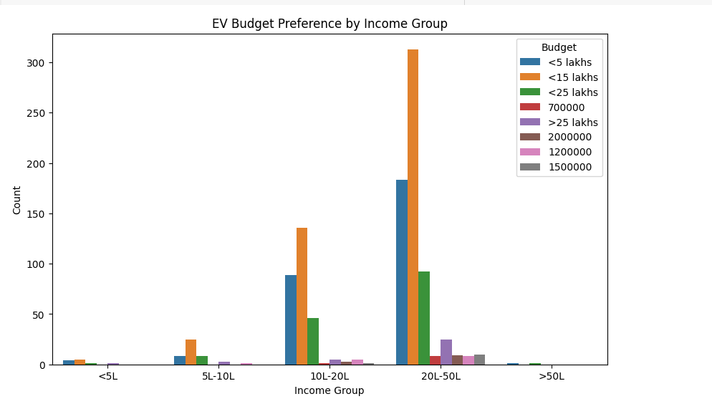

The EV budget preference data in India shows strong demand for vehicles priced under ₹15 lakhs, especially among income groups below ₹50 lakhs. The <5L and <15L categories dominate across all segments, including higher-income groups, highlighting the widespread preference for affordable EVs. The 20L–50L income group emerges as the most promising market, with interest spanning both budget and mid-premium options. Ultra-premium EVs (>₹25 lakhs) see limited demand, making them a niche segment.  
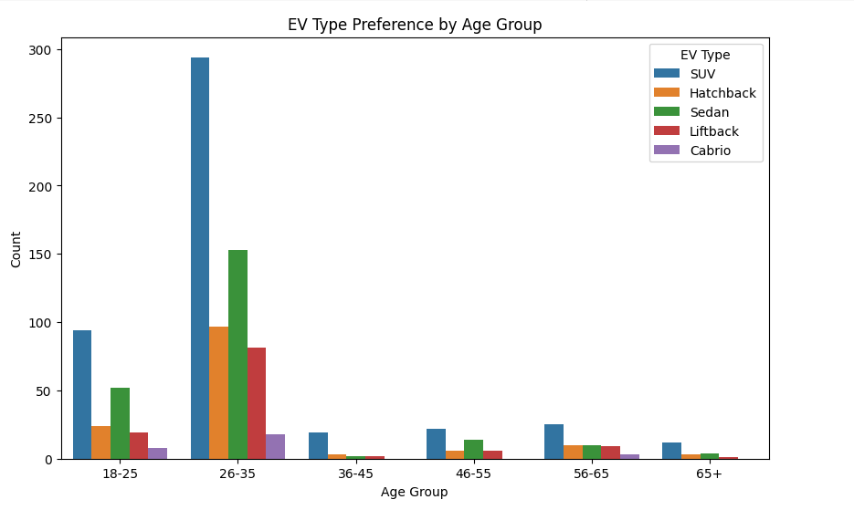

The chart highlights that SUVs are the most preferred EV type across all age groups, especially among younger consumers aged 18–35. The 26–35 age group emerges as the core EV market, showing the highest participation and strong interest in SUVs, Sedans, and Hatchbacks. In contrast, the 36–45 age group shows a notable drop in engagement, indicating a potential opportunity for targeted marketing. Older age groups (46+) display moderate to low interest, with more balanced but subdued preferences. Overall, EV adoption is driven by younger, lifestyle-oriented consumers who view EVs as modern and aspirational.

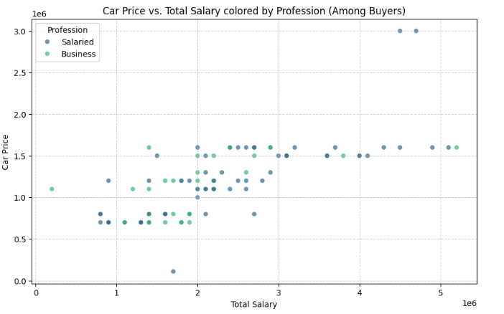

As the total salary increases, the car price is higher.

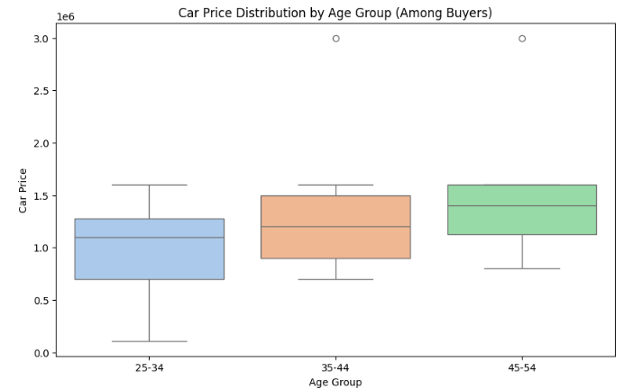

Age group 45-54 can afford higher car price as they might be well settled in their careers or occupations and earn well than the younger age groups.

**Geographic Factors**

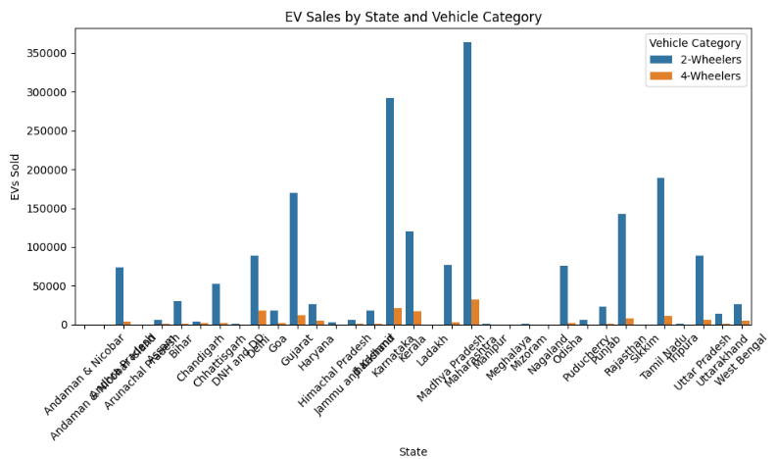

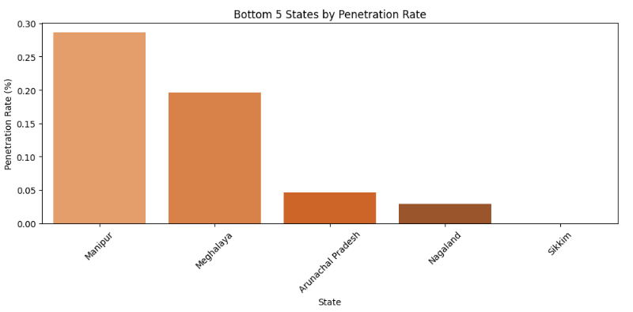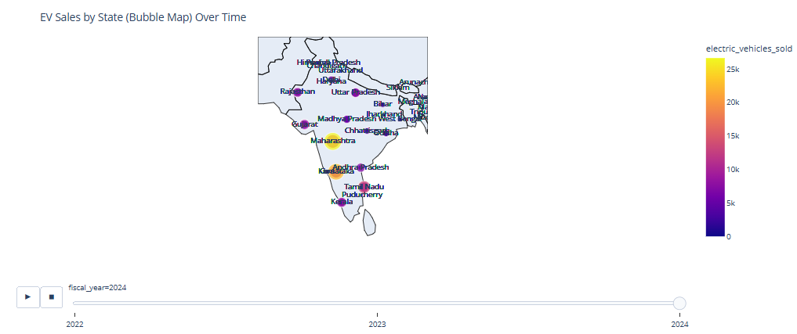

**b. Prophet**

Prophet is an open-source time series forecasting library developed by Meta AI, designed for business and economic data with trends, seasonality, and holidays. It’s built in Python (and R), user-friendly, and robust to missing data, outliers, and trend shifts, making it ideal for forecasting EV sales trends in your datasets.

**Mechanics**:

1. **Input**: Requires a DataFrame with columns ds (date, datetime format) and y (value to forecast, e.g., sales).
2. **Fitting**: Uses Bayesian inference or maximum a posteriori (MAP) estimation to fit the model, automatically detecting changepoints and seasonality.
3. **Forecasting**: Generates future predictions with uncertainty intervals (e.g., 80% confidence bounds).
4. **Components**: Outputs trend, seasonality, and holiday effects separately for analysis.
5. **Robustness**: Handles missing data, outliers, and non-uniform time intervals effectively.

**Key Features**:

* Automatic changepoint detection for trend shifts.
* Customizable seasonality (yearly, monthly, weekly).
* Holiday effects for specific events.
* Scalable for large datasets with fast computation.

**Application to the Project**:

* **Use Case**: Forecast state-wise or manufacturer-wise EV sales (e.g., 2-wheeler sales in Maharashtra) using dim_date.csv and electric_vehicle_sales_by_state.csv.

**EV Sales Forecasting (2025+)**

* Goal: Predict future EV sales by state/category
* Model: Time Series (e.g., ARIMA, Prophet) or Regression (e.g., XGBoost)
* Features: state, fiscal_year, quarter, vehicle_category

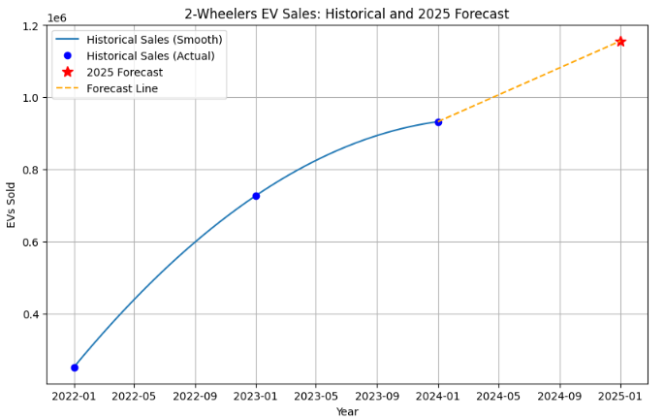

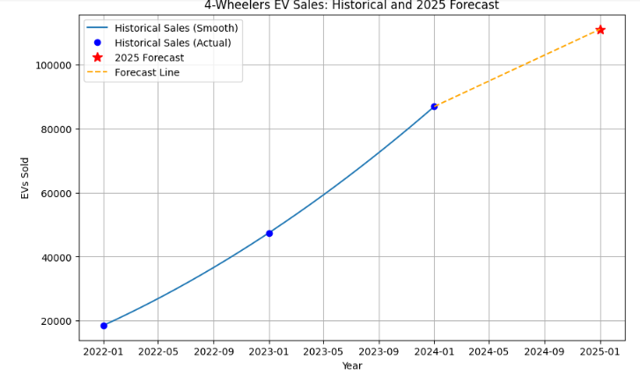

**Revenue Forecasting**

* Goal: Estimate future revenue using average prices
* Model: Extend from EV sales forecasting
* Prices: ₹85,000 (2W), ₹15,00,000 (4W)
* Output: Revenue per state/year/category

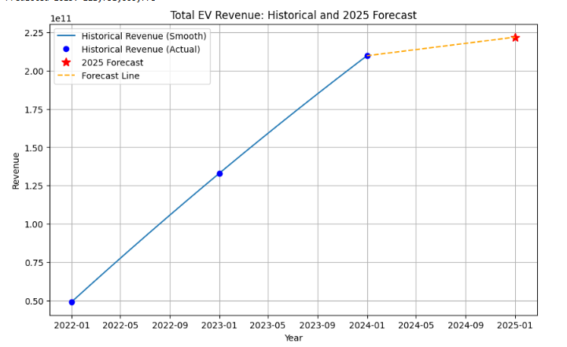

**Penetration Rate Prediction**

* Goal: Estimate future EV penetration as % of total vehicles
* Model: Regression (e.g., Linear, Ridge, RandomForest)
* Features: Total vehicles, historical EV sales, year, state

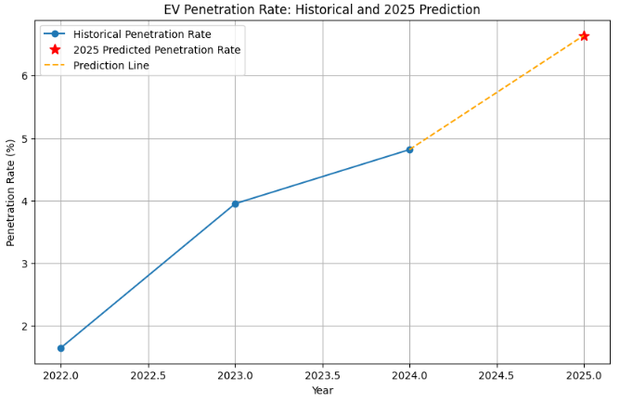

**c. Random Forest:**

**Overview**: Random Forest is an ensemble machine learning algorithm that combines multiple decision trees to improve prediction accuracy and robustness. It’s versatile for regression (e.g., predicting sales) and classification (e.g., segmenting customers).

**How Random Forest Works**:

1. **Decision Trees**:
   * Each tree splits data based on features (e.g., state, fiscal year, vehicle type) to predict an outcome (e.g., sales or customer segment).
2. **Bagging (Bootstrap Aggregating)**:
   * Randomly samples subsets of the dataset with replacement to train each tree, reducing overfitting.
3. **Random Feature Selection**:
   * At each split, uses a random subset of features to ensure diversity among trees (e.g., selecting state or date randomly).
4. **Aggregation**:
   * For regression: Averages predictions across trees.
   * For classification: Takes majority vote.
5. **Advantages**:
   * Handles non-linear relationships, missing data, and feature importance (e.g., identifying if state drives sales more than date).

**Application to the Project**:

* **Use Case**: Predict EV sales by state or classify customers into segments (e.g., young professionals vs. commercial users) using features like state, fiscal year, or vehicle type from the datasets

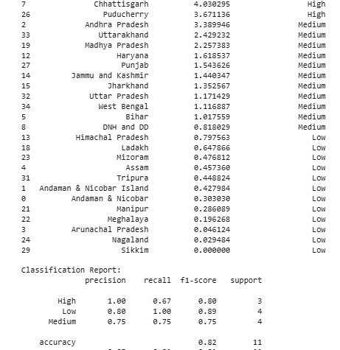

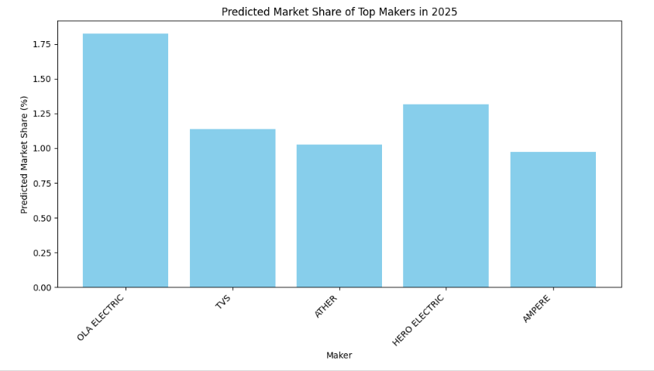

The below is the plot of feature importance in battery performance. Random Forest Model has been used here to predict the battery performance.

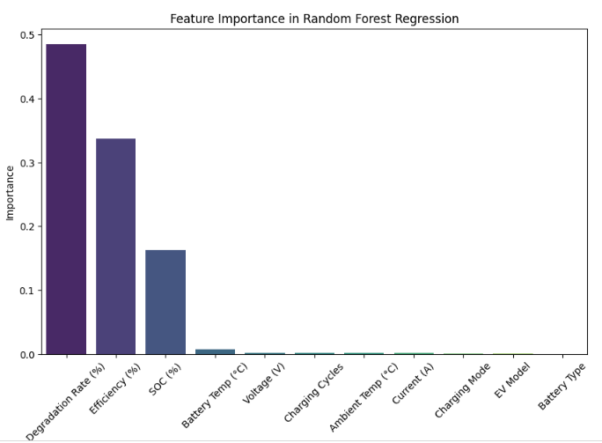

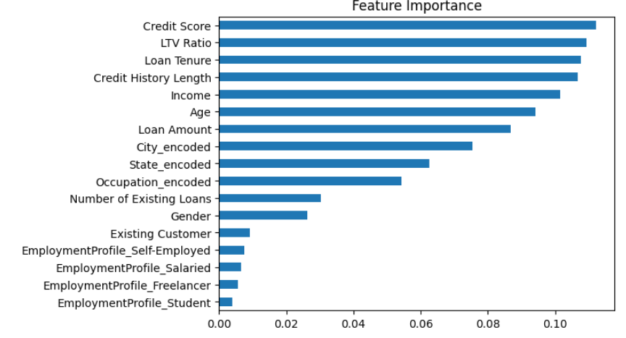

**6. Target Segments**

Based on the analysis, the target segment can be narrowed down to EVs having:

* Demographic factors such as age, income, number of dependents
* Behavioural factors such as good Acceleration and viable Price range
* Geographic factors such as States which are more market friendly

In conclusion, the target segment should comprise of EVs having Acceleration of 7.5-10 sec, High in Comfort and Value for Money ratings, have a Price range of 20-30 Lakhs, and be focused mainly on States such as Maharashtra, Karnataka, Tamil Nadu and Rajasthan.

**7. Customizing the market mix**

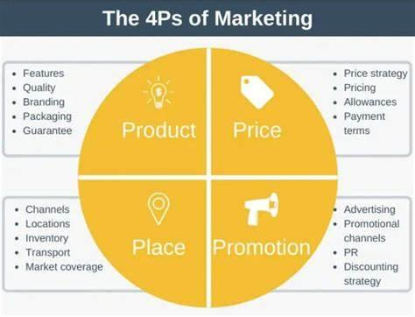**­­**

The marketing mix, comprising the 4Ps (Product, Place, Promotion, and Price), is a critical framework for driving business growth in the automotive industry by aligning strategies with the target market as outlined in the marketing plan. The company aims to maximize sales and strengthen its market presence through a robust competitive position. However, strategic decision-makers must maintain flexibility in their approaches to adapt to evolving market dynamics. The automotive sector presents significant growth opportunities, particularly for products incorporating advanced computing technologies. Concurrently, the company faces external threats in its business environment. By leveraging SWOT analysis, managers can strategically adjust the 4Ps to capitalize on opportunities and mitigate threats, ensuring sustained competitiveness and market relevance.

**Product Mix**

The product component of the marketing mix encompasses the company's offerings, with each product line representing a distinct group of outputs or products. The complete set of product lines constitutes the product mix, reflecting a strategic level of business diversification. In the context of the automotive industry, the company provides a diverse portfolio, including various brands, types, and models of electric vehicles (EVs), tailored to meet the needs of target market segments such as young professionals, urban families, and commercial operators.

* Automobiles
* Automobile parts
* Commercial vehicles
* Financial services

**Prices and Pricing Strategies**

The pricing component of the marketing mix focuses on establishing optimal price points and ranges for the company’s electric vehicle (EV) products to align with market expectations and business objectives. Strategic pricing shapes the perceived value of brands and models, significantly influencing sales performance in price-sensitive markets such as India, where affordability drives consumer adoption across diverse segments. The pricing strategies for its automotive products are as follows:

* Market-oriented pricing strategy
* Premium pricing strategy

**Promotional Mix**

Promotional activities are considered in this aspect of marketing mix of 4Ps. These activities are also known as marketing communications tactics. The combination of these tactics is called a promotional mix or marketing communications mix the following promotional activities are used, arranged according to significance in the automotive business:

* Advertising (primary)
* Direct marketing
* Personal selling
* Sales promotion
* Public relations

**Place/Distribution**

In this aspect of marketing mix or 4Ps, the virtual or physical locations of transactions are considered. Such locations are significant because they enable the company to reach target customers in specific markets, while also allowing customers to access information and products available from the automotive business. The following places are used in the distribution of products and services:

* Official websites
* Dealerships
* Automotive shows and exhibits

**8. Most Optimal Market Segment**

Based on comprehensive analysis of demographics, psychographics, behavioral patterns, and geographic factors from both the primary survey and external datasets, the following is identified as the **most optimal market segment** for electric vehicles (EVs) in India.

### Demographic Profile:

* **Age Group:** 25–40 years
* **Income Range:** ₹10–30 Lakhs annually
* **Education Level:** Graduate or above
* **Family Size:** 3–5 members
* **Profession:** Urban professionals, tech-savvy, or early adopters

### Geographic Concentration:

* Urban cities in states like **Maharashtra, Karnataka, Delhi, Tamil Nadu**
* Areas with well-established **charging infrastructure** and **government incentives**

### Psychographic Traits:

* Environmentally conscious
* Interested in modern technology and connected mobility
* Cost-conscious but willing to invest in long-term savings through EV adoption

### Behavioural Indicators:

* Prefer **SUVs** and **Hatchbacks** for space, comfort, and practicality
* Willing to spend up to ₹15–20 Lakhs on EVs
* Believe EVs will replace fuel vehicles in India within the next 10–20 years
* Favour 2-wheeler EVs for daily commuting and 4-wheelers for family utility

### Strategic Opportunity:

This segment represents the **early majority** in EV adoption. They are motivated by a blend of **economic, environmental, and technological** benefits. Targeting this segment with mid-range EV models, clear information on total cost savings, and accessible financing or subsidies can significantly boost EV adoption in India.

**In conclusion**, **young urban professionals and families in metro cities** represent the most promising segment for EV expansion, both in 2W and 4W categories. A well-aligned product offering and tailored marketing can accelerate market penetration in this group.

### 9. Maximizing Potential Sales in the Early Market for Electric Vehicles in India

The acquisition of an electric vehicle (EV) represents a significant milestone for consumers, particularly families seeking sustainable and practical transportation solutions tailored to their needs, such as commuting, schooling, and urban or suburban lifestyles. To address these demands, the company leverages data-driven insights to guide consumers in selecting optimal EVs at competitive, region-specific price points, factoring in market dynamics, infrastructure availability, and consumer preferences.

To drive the adoption and growth of EVs in India’s early market phase, the following strategic imperatives must be prioritized within the marketing mix framework to enhance sales potential and establish a robust market presence:

1. **Retrofitting Public and Commercial Transport**: Converting public transport buses, taxis, and three-wheelers (auto-rickshaws) to plug-in hybrid electric vehicles (PHEVs) is critical for advancing sustainable transportation. This initiative reduces emissions, alleviates infrastructure demands, and aligns with urban mobility needs, appealing to environmentally conscious early adopters.
2. **Government Incentives**: Strategic incentives are essential to accelerate EV adoption by mitigating the primary barrier of high upfront costs. Key measures include:
   * Subsidy schemes to bridge the price gap between internal combustion engine (ICE) vehicles and EVs. For instance, if an ICE vehicle costs INR 5 lakh and an equivalent EV costs INR 6.5 lakh, subsidies can offset the INR 1.5 lakh differential.
   * Additional benefits, such as discounts on VAT, vehicle registration fees, and toll charges, to incentivize EV purchases and enhance perceived value in price-sensitive markets.
3. **Charging Infrastructure Development**: Robust charging infrastructure is foundational to EV market growth. Strategic actions include:
   * Deploying grid-connected charging stations with moderate tariffs to ensure affordability.
   * Promoting standalone renewable energy (solar/wind) charging stations at petrol pumps, bus stops, and state transport hubs.
   * Encouraging private investment in renewable charging stations to expand accessibility and support early market adoption.
4. **Electrical Propulsion System (EPS) Development**: The absence of domestically manufactured EPS in India, exemplified by REVA’s reliance on Italian suppliers, underscores the need for local production. Strategic initiatives include:
   * Formulating policies to support the supply, manufacturing, and recycling of EPS components, including power electronics converters and motors, leveraging India’s existing technological capabilities.
   * Addressing challenges in cost-effective lithium-ion battery production, given limited domestic lithium resources, and promoting battery swapping or replacement models as viable solutions to enhance affordability and convenience.
5. **Skilled Manpower Development**: The adoption of advanced EV technologies necessitates a workforce of certified technicians and professionals. Investments in training programs and certifications will ensure safety, quality, and consumer trust, supporting early market growth.
6. **Consumer Awareness and Promotion**: Raising awareness of EV benefits is crucial to drive demand among early adopters. Comprehensive promotional strategies include:
   * Extensive campaigns across print media (newspapers, magazines), digital platforms (social media, internet), radio, and television, as well as public displays (banners, hoardings) at airports, bus stations, and government offices.
   * Educational initiatives, such as micro-funding for EV-related projects in schools and colleges, R&D grants for research institutions, and expert-led talks or TV shows.
   * Highlighting consumer benefits, including:
     + **Environmental Impact**: EVs emit significantly lower levels of pollutants (e.g., nitrogen oxides, particulate matter, CO2) compared to ICE vehicles.
     + **Cost Efficiency**: Lower electricity costs result in reduced running expenses compared to petrol or diesel vehicles.
     + **Lower Lifecycle Costs**: EVs offer reduced maintenance and operational costs over their lifespan.
     + **Urban Suitability**: Minimal noise and pollution make EVs ideal for urban environments.
     + **Performance**: Smooth, gearless acceleration and deceleration enhance driving comfort.
     + **Quiet Operation**: Near-silent operation improves user experience and reduces noise pollution.
     + **Proven Technology**: Global EV market growth validates the reliability and scalability of EV technology.

By strategically aligning these initiatives with the marketing mix, particularly through competitive pricing, targeted promotions, and robust distribution channels, the company can maximize potential sales in India’s early EV market, appealing to family-oriented consumers and early adopters in urban and semi-urban regions.

### 10. Identifying the Most Optimal Market Segment for Electric Vehicles in India

The Indian electric vehicle (EV) market is characterized by a competitive landscape with established players such as Hero Electric, Tata Motors, Ather Energy, Ashok Leyland, and Hyundai Kona Electric, alongside emerging global entrants like Tesla. As demand for EVs grows, driven by automotive industry investments and supportive government policies, the market is poised for significant expansion, though full integration will require time to address infrastructure and adoption challenges. The following key insights inform the identification of the most optimal market segment for the company’s strategic entry:

1. **Market Recovery and Growth Potential**: Despite setbacks from the COVID-19 pandemic, which temporarily disrupted the EV industry, the sector is projected to experience substantial growth in the coming years, driven by increasing consumer awareness, environmental imperatives, and policy support.
2. **Environmental and Operational Benefits**: EVs offer transformative advantages, including reduced air and noise pollution, lower emissions, and enhanced fuel efficiency, positioning them as a sustainable alternative to internal combustion engine (ICE) vehicles and aligning with India’s environmental goals.
3. **Strategic Local Operations**: To establish a competitive presence, the company should prioritize local operations through partnerships with Indian manufacturers or by establishing its own manufacturing and development facilities. A hybrid approach, combining local production with selective imports of critical components, will optimize cost efficiency and compliance with local regulations.
4. **Targeted Segment Focus**: The company should target the commercial fleet market, particularly two-wheelers and three-wheelers used for last-mile delivery and urban freight services, which exhibit strong growth potential in India’s urban centers. Opportunities also exist across the EV supply chain, including battery production, component manufacturing, charging infrastructure, and the provision of machinery, equipment, and skilled workforce training to support manufacturing scale-up.
5. **Phased Market Entry**: The company should initiate operations in metropolitan cities (e.g., Bengaluru, Delhi NCR, Mumbai, Chennai) to leverage established infrastructure, high consumer demand, and early adopter segments. Following successful establishment, expansion into secondary cities within the same states will facilitate scalable growth, utilizing existing supply chain networks and market insights gained from metro operations.

**Conclusion**: Electric vehicles represent the future of sustainable mobility in India, offering significant environmental and economic benefits. By strategically targeting the commercial two-wheeler and three-wheeler segments in metropolitan cities, the company can capitalize on early market opportunities and contribute to India’s green mobility revolution, encapsulated in the vision: “Go Green, Go Electric.”

**Github links:**

<https://github.com/Neeharika457/EV-Market-Segmentation>

<https://github.com/harikavemula91/EV-Vehicle-with-demographic-data-for-startup-target>

<https://github.com/EV-Market-Analysis-Dashboard>

<https://github.com/amal957/Market-Segmentation>

­